

INSTITUTE OF COMPUTER SCIENCE & DIGITAL INNOVATION
September - January Intake 2025-09 (Long Semester)

BIC2323 Database Technology

Group Assignment

Lecturer:
Asst. Prof. Dr. Chloe Thong Chee Ling

Submitted by:
Name | Student ID
Nathanael Patrick Theseira | 1002475460
Lan Xin Yan | 1002475404

Assignment 1: Writing Cursors (15 Marks)

Note:
Each team should consist of two members, and you may select your own teammate.

PL/SQL CURSORS

In order to perform the following task you will need to create a table detailed below:

EMPLOYEE
Empid number
Empname varchar2(50)
Empaddr1 varchar2(50)
Empaddr2 varchar2(50)
Empaddr3 varchar2(50)
Emppostcode varchar2(10)
Empdept varchar2(20)
Empgrade number
Empsalary number

A)Creating table
CREATE TABLE employee (
empid NUMBER PRIMARY KEY,
empname VARCHAR2(50),
empaddr1 VARCHAR2(50),
empaddr2 VARCHAR2(50),
empaddr3 VARCHAR2(50),
emppostcode VARCHAR2(10),
empdept VARCHAR2(20),
empgrade NUMBER,
empsalary NUMBER);

B)10 rows of details
INSERT INTO employee VALUES (1001, 'Alice', 'A1', NULL, NULL, '43000', 'HR', 1, 12000);
INSERT INTO employee VALUES (1002, 'Bob', 'B1', NULL, NULL, '43200', 'IT', 2, 18000);
INSERT INTO employee VALUES (1003, 'Cara', 'C1', NULL, NULL, '45000', 'FIN',3, 20000);
INSERT INTO employee VALUES (1004, 'Dan', 'D1', NULL, NULL, '46000', 'OPS',4, 23000);
INSERT INTO employee VALUES (1005, 'Eve', 'E1', NULL, NULL, '43700', 'IT', 5, 28000);
INSERT INTO employee VALUES (1006, 'Fay', 'F1', NULL, NULL, '43700', 'HR', 1, 14950);
INSERT INTO employee VALUES (1007, 'Gus', 'G1', NULL, NULL, '43200', 'OPS',2, 14000);
INSERT INTO employee VALUES (1008, 'Hana', 'H1', NULL, NULL, '43000', 'FIN',3, 21950);
INSERT INTO employee VALUES (1009, 'Ivan', 'I1', NULL, NULL, '45000', 'IT', 4, 25450);
INSERT INTO employee VALUES (1010,'Jade', 'J1', NULL, NULL, '46000', 'FIN',5, 29950);
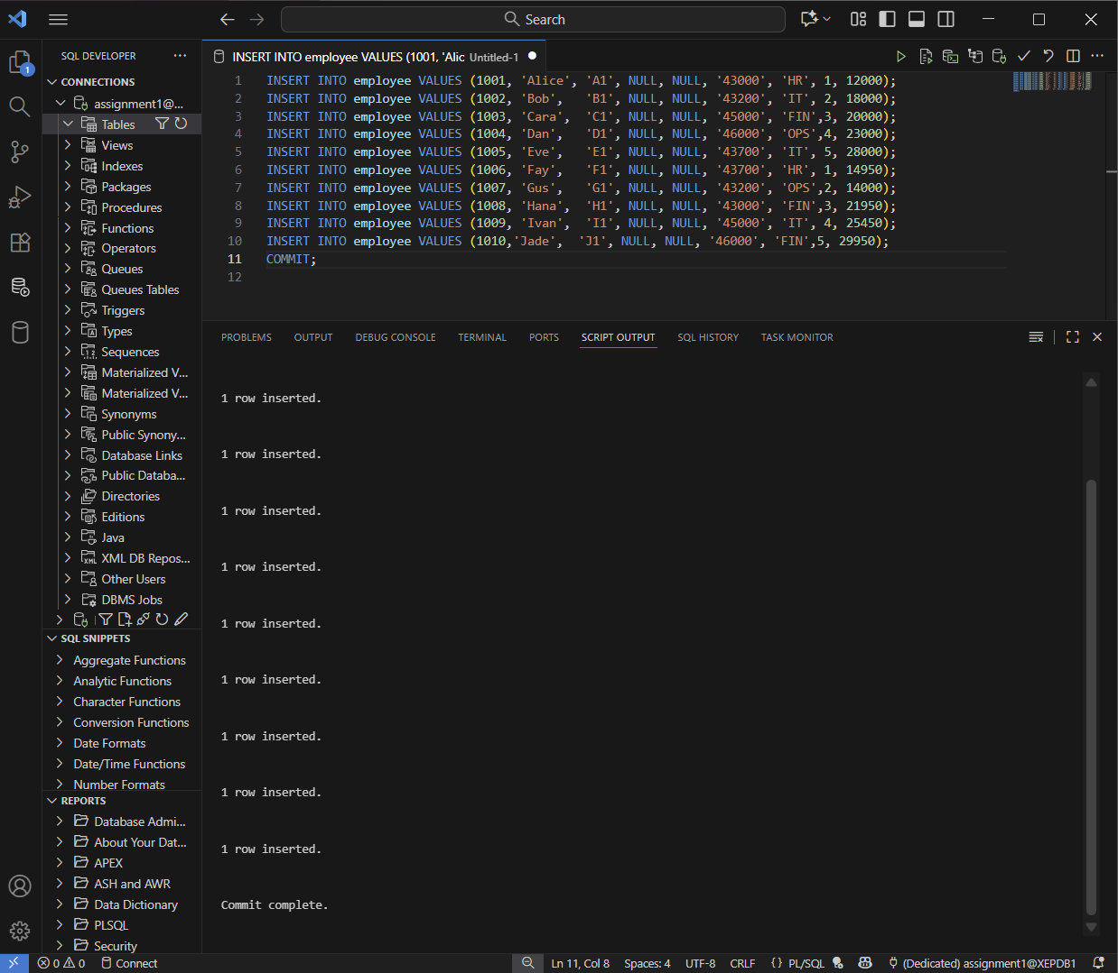
Figure 1: Employee table created using SQL DDL command, defining fields such as employee ID, name, department, grade, and salary.
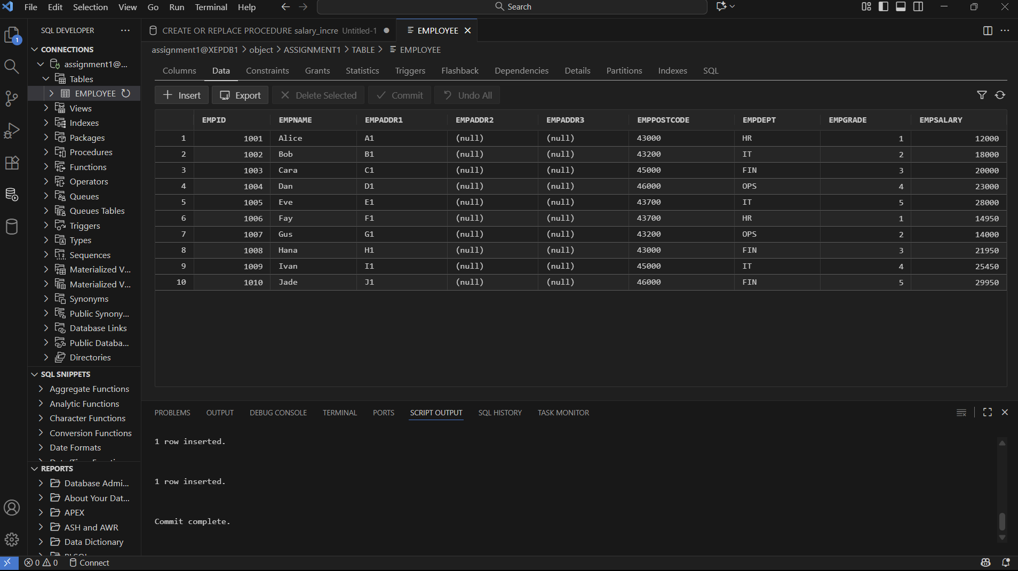Figure 2: Insertion of ten employee records into the employee table using SQL DML statements. This data will be used to test the salary update procedure.

The purpose of this exercise is to create a procedure which, when evoked, will increase the salary of a grade by £500 or £1000 depending on the level of the grade. You will need to populate the table first with a minimum of 10 entries, the empgrade value should be between 1 and 5, and the idea is the higher the grade the higher the manager.
The code below will create the procedure but you will need to fill in the missing bits indicated by BOLD letters. Once you have done this you should compile the code by entering @salary_increase at your SQL prompt once logged on. This will then indicate if the procedure has compiled or not. If compilation is unsuccessful entering the command show errors will list any problems with the code. To run the procedure you type execute salary_increase at the SQL prompt.
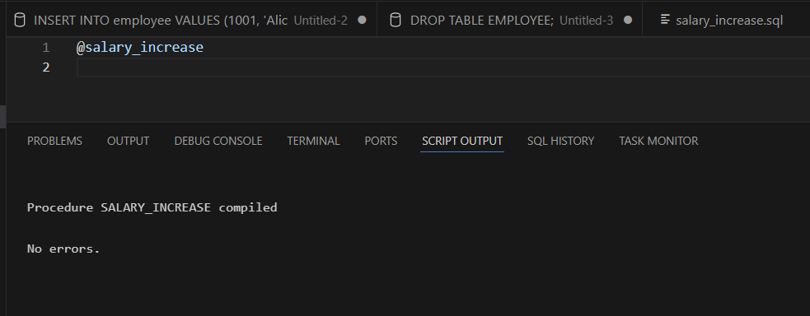
Figure 3 :Screenshot showing the compilation is successful after enter the
@salary_increase
NOTES:
Remember that you need to have a variable to store each component of the return from the cursor.
Where an IF statement is used remember to END IF;
The salaries for the grades are listed below:

Grade | Salary Range
1 | 10000-15000
2 | 14000-19500
3 | 19000-22000
4 | 21500-25500
5 | 25000-30000

Question 1:

Complete the code below, you should include a cursor which will select the grade, salary and employee id for each record. You should then use this information to check the grade and increase salary accordingly. The criteria for increase is given in the procedure below.

CREATE OR REPLACE PROCEDURE salary_increase AS
Declare the cursor and variables here without DECLARE
BEGIN

Open the cursor :

LOOP
FETCH complete the fetch command
EXIT WHEN cursor name%NOTFOUND; /*this will exit when cursor empty*/

Check using if statement if the grade is < 4 if so increase salary by 500D
Check using if statement if the grade is > 3 if so increase salary by 1000
END LOOP;
END;

Once this is completed compile the code and correct any errors if any are noted.

Execute the procedure and note the changes to the salary.

1A) Answer for Question 1
CREATE OR REPLACE PROCEDURE salary_increase AS
CURSOR emp_cur IS
SELECT empid, empgrade, empsalary
FROM employee;

v_empid employee.empid%TYPE;
v_empgrade employee.empgrade%TYPE;
v_salary employee.empsalary%TYPE;
BEGIN
OPEN emp_cur;
LOOP
FETCH emp_cur INTO v_empid, v_empgrade, v_salary;
EXIT WHEN emp_cur%NOTFOUND;

IF v_empgrade < 4 THEN
UPDATE employee
SET empsalary = v_salary + 500
WHERE empid = v_empid;

ELSIF v_empgrade > 3 THEN
UPDATE employee
SET empsalary = v_salary + 1000
WHERE empid = v_empid;
END IF;
END LOOP;

CLOSE emp_cur;
END;
/

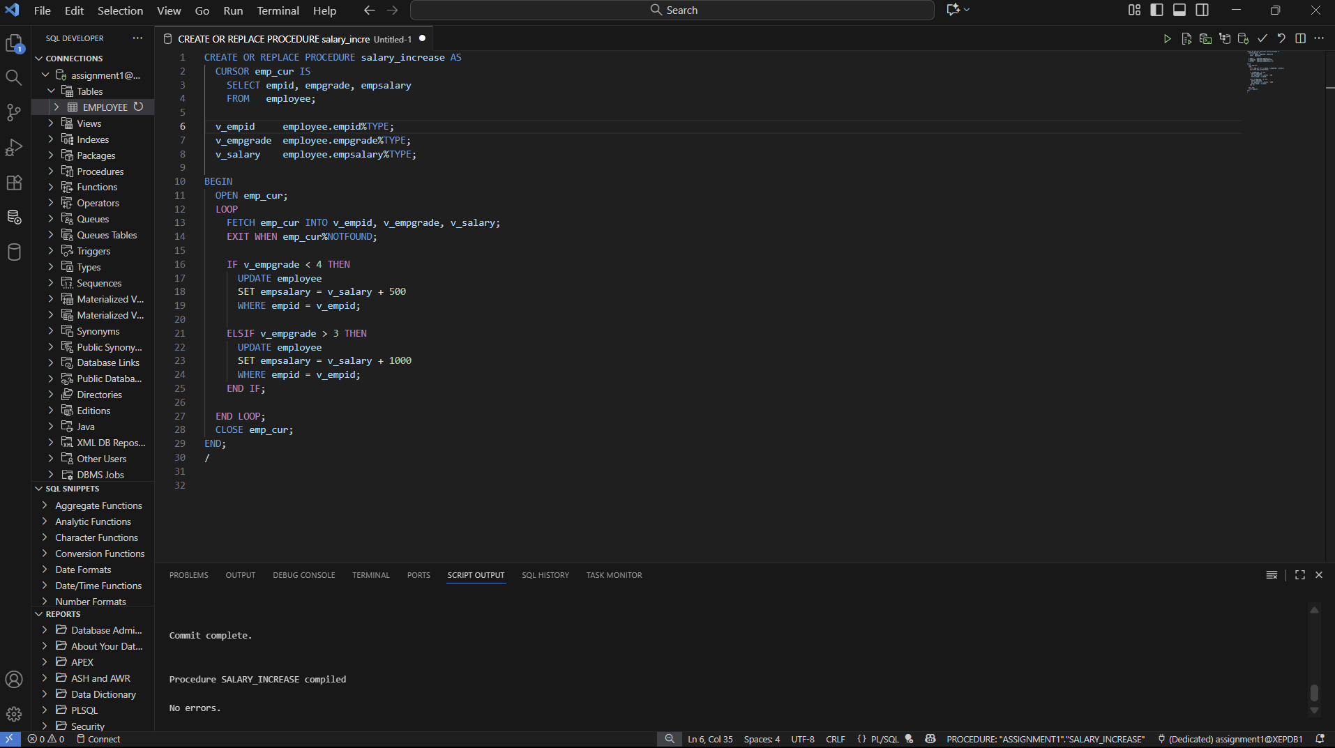
Figure 4:Screenshot showing the PL/SQL procedure of “salary_increase” for Question 1 to update employee salaries using a cursor.
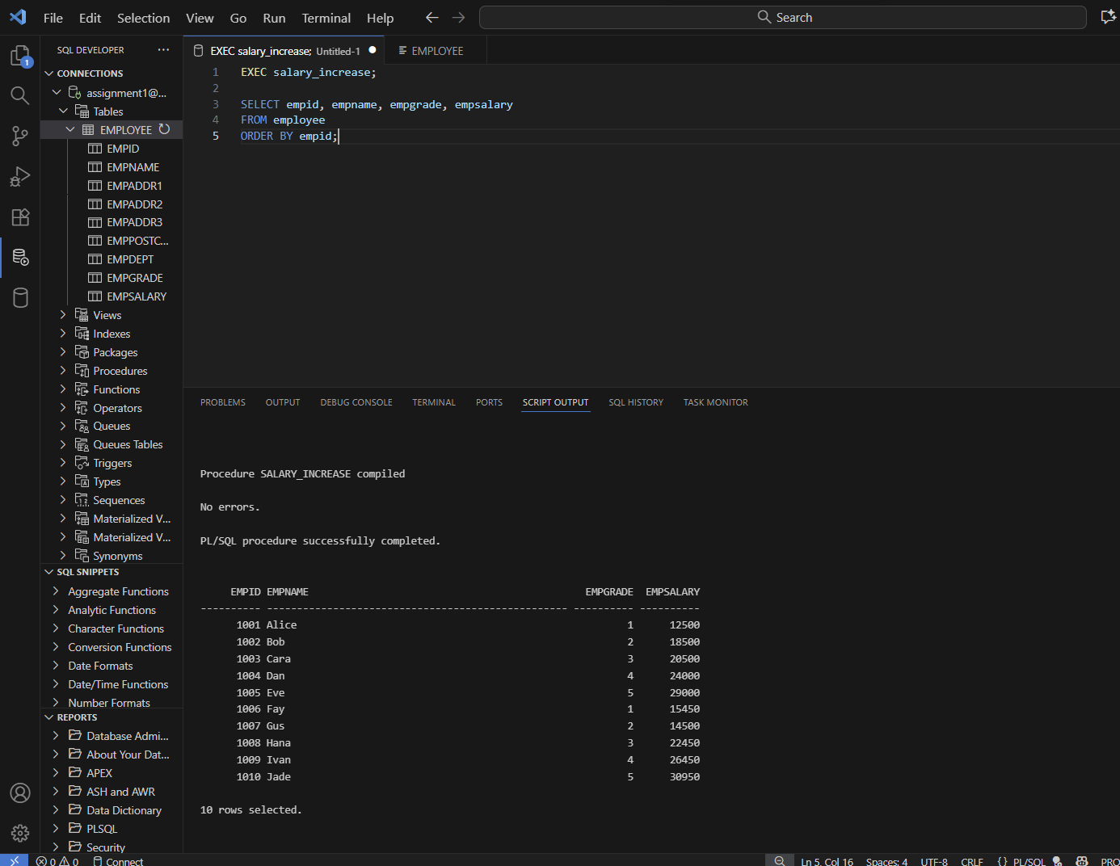Figure 5: Output after executing the salary_increase procedure from Question 1. Employee salaries have been updated according to their grade categories.

Question 2:

Amend the code so that if the salary increase takes the salary above the maximum for that grade the salary is altered to the maximum for that grade and not increased above that. (NOTE: you need to create a grade table for this task).

2A) Create table and insert data

CREATE TABLE grade (
grade NUMBER PRIMARY KEY,
minsalary NUMBER,
maxsalary NUMBER
);

INSERT INTO grade VALUES (1, 10000, 15000);
INSERT INTO grade VALUES (2, 14000, 19500);
INSERT INTO grade VALUES (3, 19000, 22000);
INSERT INTO grade VALUES (4, 21500, 25500);
INSERT INTO grade VALUES (5, 25000, 30000);

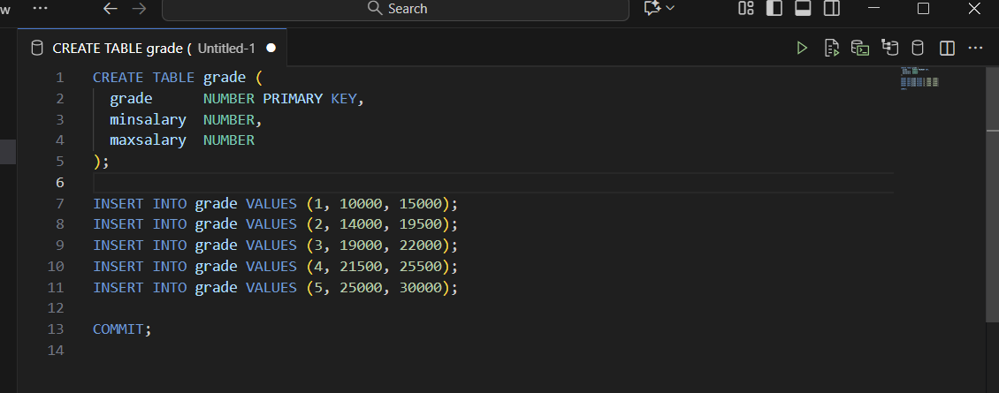
Figure 6: Creation of the grade table defining the minimum and maximum salary limits for each grade level, which will be used in Question 2.

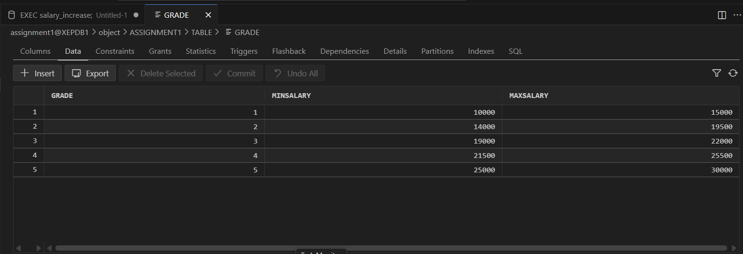
Figure 7 : Output of grade table, shows the minimum and maximum salary base on
the grade.

2B) Modified version of salary_increase for Question 2
CREATE OR REPLACE PROCEDURE salary_increase AS
CURSOR emp_cur IS
SELECT empid, empgrade, empsalary FROM employee;
v_empid employee.empid%TYPE;
v_empgrade employee.empgrade%TYPE;
v_salary employee.empsalary%TYPE;
v_maxsalary grade.maxsalary%TYPE;
v_new_salary NUMBER;
BEGIN
OPEN emp_cur;
LOOP
FETCH emp_cur INTO v_empid, v_empgrade, v_salary;
EXIT WHEN emp_cur%NOTFOUND;

SELECT maxsalary INTO v_maxsalary
FROM grade
WHERE grade = v_empgrade;

IF v_empgrade < 4 THEN
v_new_salary := v_salary + 500;
IF v_new_salary > v_maxsalary THEN
v_new_salary := v_maxsalary;
END IF;
UPDATE employee SET empsalary = v_new_salary WHERE empid = v_empid;

ELSIF v_empgrade > 3 THEN
v_new_salary := v_salary + 1000;
IF v_new_salary > v_maxsalary THEN
v_new_salary := v_maxsalary;
END IF;
UPDATE employee SET empsalary = v_new_salary WHERE empid = v_empid;
END IF;
END LOOP;
CLOSE emp_cur;
END;
/

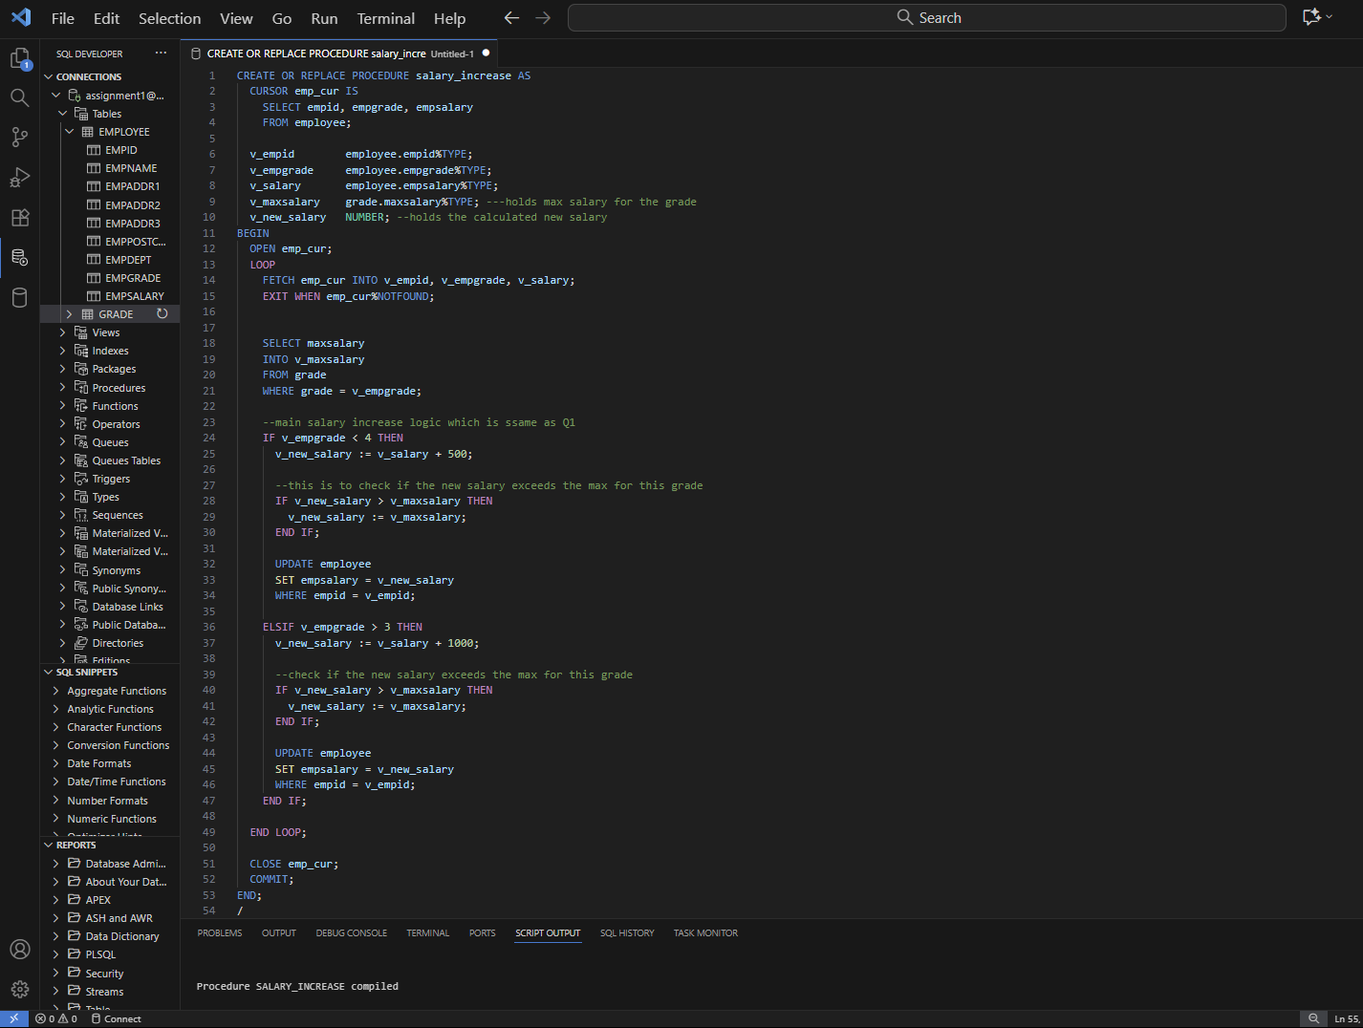
Figure 8:Screenshot showing the implementation of the modified stored procedure for Question 2 , showing the inclusion of cursor logic and maximum salary limit conditions

The code for execute updated salary for Q2
EXEC salary_increase;

SELECT empid, empname, empgrade, empsalary FROM employee ORDER BY empid;

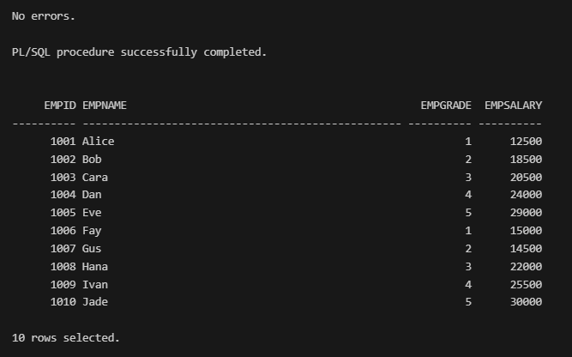

Figure 9 : Final output after executing the modified procedure for Question 2, confirming that employee salaries have increased correctly and do not exceed their grade maximum limits.

Conclusion:
In this assignment, we successfully created and tested a PL/SQL stored procedure using a cursor to increase employee salaries based on grade level. In Question 1, salaries were incremented by RM500 or RM1000 depending on the grade. In Question 2, an additional grade table was created to define minimum and maximum salary limits, and the procedure was modified to ensure no salary exceeded the grade’s maximum range. This exercise enhanced our understanding of cursor control structures and exception handling in PL/SQL, which are essential concepts in database programming.

